FILE SYSTEM IN LINUX

Q1. which of the following is not a file system in the linux operating system?

Answer: d.mkfs

Q2. Create a file that contains only user

name and user id of all the users present on the server.

Answer: 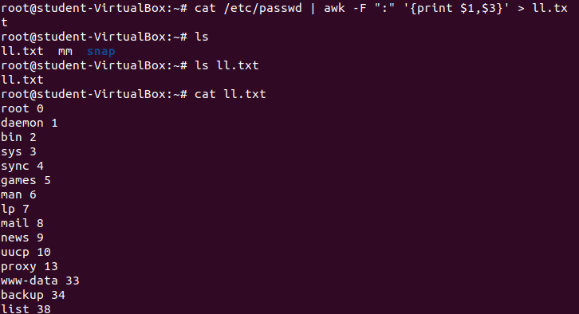

Q3. How will you provide a count of all users on the system except for adm user?

Answer:

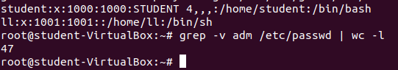

**Q4. How will you list all files in /tmpin** increasing order of their size

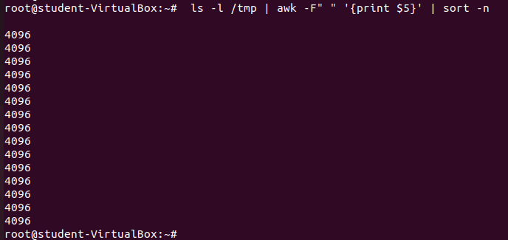

Q5. What command is used to clear history on the linux server?

Answer: history -c